**AIM:Design Web Applications using Client Side Session Management.**

**WAP to implement Client side state management techniques and Server side state management techniques on the form design attached with the assignment.**

1. **SESSION MANAGEMENT:**

**SOURCE CODE:**

**SM.aspx:**

<%@ Page Language="C#" AutoEventWireup="true" CodeFile="SM.aspx.cs" Inherits="SM" %>

<!DOCTYPE html>

<html xmlns="http://www.w3.org/1999/xhtml">

<head runat="server">

<title></title>

</head>

<body>

<form id="form1" runat="server">

<div>

Name: <asp:TextBox ID="name" runat="server"></asp:TextBox>

<br />

Age: <asp:TextBox ID="age" runat="server"></asp:TextBox>

<br />

Branch: <asp:TextBox ID="branch" runat="server"></asp:TextBox>

<br />

<asp:Button ID="Button1" runat="server" OnClick="Button1_Click" Text="Submit" />

</div>

</form>

</body>

</html>

**SM.aspx.cs:**

using System;

using System.Collections.Generic;

using System.Linq;

using System.Web;

using System.Web.UI;

using System.Web.UI.WebControls;

public partial class SM : System.Web.UI.Page

{

protected void Page_Load(object sender, EventArgs e)

{

}

protected void Button1_Click(object sender, EventArgs e)

{

Session["name"] = name.Text;

Session["age"] = age.Text;

Session["branch"] = branch.Text;

Response.Redirect("SM2.aspx");

}

}

**SM2.aspx:**

<%@ Page Language="C#" AutoEventWireup="true" CodeFile="SM2.aspx.cs" Inherits="SM2" %>

<!DOCTYPE html PUBLIC "-//W3C//DTD XHTML 1.0 Transitional//EN" "http://www.w3.org/TR/xhtml1/DTD/xhtml1-transitional.dtd">

<html xmlns="http://www.w3.org/1999/xhtml">

<head runat="server">

<title></title>

</head>

<body>

<form id="form1" runat="server">

<div>

Name: <asp:Label ID="name" runat="server"></asp:Label>

<br />

Age: <asp:Label ID="age" runat="server"></asp:Label>

<br />

Branch: <asp:Label ID="branch" runat="server"></asp:Label>

<br />

</div>

</form>

</body>

</html>

**SM2.aspx.cs:**

using System;

using System.Collections.Generic;

using System.Linq;

using System.Web;

using System.Web.UI;

using System.Web.UI.WebControls;

public partial class SM2 : System.Web.UI.Page

{

protected void Page_Load(object sender, EventArgs e)

{

if (Session["name"] != null)

{

name.Text = Session["name"].ToString();

}

if (Session["age"] != null)

{

age.Text = Session["age"].ToString();

}

if (Session["branch"] != null)

{

branch.Text = Session["branch"].ToString();

}

}

}

**OUTPUT:**

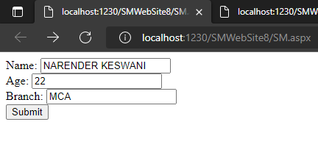

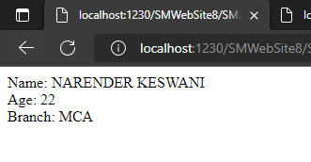

1. **COOKIE:**

**SOURCE CODE:**

**Cookie.aspx:**

<%@ Page Language="C#" AutoEventWireup="true" CodeFile="Cookie.aspx.cs" Inherits="Cookie" %>

<!DOCTYPE html PUBLIC "-//W3C//DTD XHTML 1.0 Transitional//EN" "http://www.w3.org/TR/xhtml1/DTD/xhtml1-transitional.dtd">

<html xmlns="http://www.w3.org/1999/xhtml">

<head runat="server">

<title></title>

</head>

<body>

<form id="form1" runat="server">

<div>

Name: <asp:TextBox ID="name" runat="server"></asp:TextBox>

<br />

Age: <asp:TextBox ID="age" runat="server"></asp:TextBox>

<br />

Branch: <asp:TextBox ID="branch" runat="server"></asp:TextBox>

<br />

<asp:Button ID="Button1" runat="server" OnClick="Button1_Click" Text="Submit" />

</div>

</form>

</body>

</html>

**Cookie.aspx.cs:**

using System;

using System.Collections.Generic;

using System.Linq;

using System.Web;

using System.Web.UI;

using System.Web.UI.WebControls;

public partial class Cookie : System.Web.UI.Page

{

protected void Page_Load(object sender, EventArgs e)

{

}

protected void Button1_Click(object sender, EventArgs e)

{

HttpCookie userInfo = new HttpCookie("userInfo");

userInfo["name"] = name.Text;

userInfo["age"] = age.Text;

userInfo["branch"] = branch.Text;

Response.Cookies.Add(userInfo);

Response.Redirect("C2.aspx");

}

}

**C2.aspx:**

<%@ Page Language="C#" AutoEventWireup="true" CodeFile="C2.aspx.cs" Inherits="C2" %>

<!DOCTYPE html PUBLIC "-//W3C//DTD XHTML 1.0 Transitional//EN" "http://www.w3.org/TR/xhtml1/DTD/xhtml1-transitional.dtd">

<html xmlns="http://www.w3.org/1999/xhtml">

<head runat="server">

<title></title>

</head>

<body>

<form id="form1" runat="server">

<div>

Name: <asp:Label ID="name" runat="server"></asp:Label>

<br />

Age: <asp:Label ID="age" runat="server"></asp:Label>

<br />

Branch: <asp:Label ID="branch" runat="server"></asp:Label>

<br />

</div>

</form>

</body>

</html>

**C2.aspx.cs:**

using System;

using System.Collections.Generic;

using System.Linq;

using System.Web;

using System.Web.UI;

using System.Web.UI.WebControls;

public partial class C2 : System.Web.UI.Page

{

protected void Page_Load(object sender, EventArgs e)

{

HttpCookie reqCookies = Request.Cookies["userInfo"];

if (reqCookies != null)

{

name.Text = reqCookies["name"].ToString();

age.Text = reqCookies["age"].ToString();

branch.Text = reqCookies["branch"].ToString();

}

}

}

**OUTPUT:**

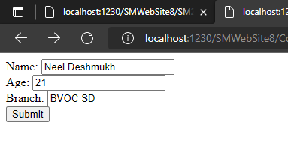

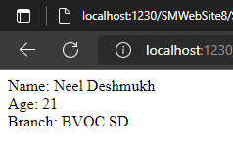

1. **QUERY STRINGS:**

**SOURCE CODE:**

**QueryString.aspx:**

<%@ Page Language="C#" AutoEventWireup="true" CodeFile="QueryString.aspx.cs" Inherits="QueryString" %>

<!DOCTYPE html PUBLIC "-//W3C//DTD XHTML 1.0 Transitional//EN" "http://www.w3.org/TR/xhtml1/DTD/xhtml1-transitional.dtd">

<html xmlns="http://www.w3.org/1999/xhtml">

<head runat="server">

<title></title>

</head>

<body>

<form id="form1" runat="server">

<div>

Name: <asp:TextBox ID="name" runat="server"></asp:TextBox>

<br />

Age: <asp:TextBox ID="age" runat="server"></asp:TextBox>

<br />

Branch: <asp:TextBox ID="branch" runat="server"></asp:TextBox>

<br />

<asp:Button ID="Button1" runat="server" OnClick="Button1_Click" Text="Submit" />

</div>

</form>

</body>

</html>

**QueryString.aspx.cs:**

using System;

using System.Collections.Generic;

using System.Linq;

using System.Web;

using System.Web.UI;

using System.Web.UI.WebControls;

public partial class QueryString : System.Web.UI.Page

{

protected void Page_Load(object sender, EventArgs e)

{

}

protected void Button1_Click(object sender, EventArgs e)

{

Response.Redirect("QS2.aspx?name=" + name.Text + "&age=" + age.Text + "&branch=" + branch.Text);

}

}

**QS2.aspx:**

<%@ Page Language="C#" AutoEventWireup="true" CodeFile="QS2.aspx.cs" Inherits="QS2" %>

<!DOCTYPE html PUBLIC "-//W3C//DTD XHTML 1.0 Transitional//EN" "http://www.w3.org/TR/xhtml1/DTD/xhtml1-transitional.dtd">

<html xmlns="http://www.w3.org/1999/xhtml">

<head runat="server">

<title></title>

</head>

<body>

<form id="form1" runat="server">

<div>

Name: <asp:Label ID="name" runat="server"></asp:Label>

<br />

Age: <asp:Label ID="age" runat="server"></asp:Label>

<br />

Branch: <asp:Label ID="branch" runat="server"></asp:Label>

<br />

</div>

</form>

</body>

</html>

**QS2.aspx.cs:**

using System;

using System.Collections.Generic;

using System.Linq;

using System.Web;

using System.Web.UI;

using System.Web.UI.WebControls;

public partial class QS2 : System.Web.UI.Page

{

protected void Page_Load(object sender, EventArgs e)

{

string names = Request.QueryString["name"];

string ages = Request.QueryString["age"];

string branchs = Request.QueryString["branch"];

name.Text = names;

age.Text = ages;

branch.Text = branchs;

}

}

**OUTPUT:**

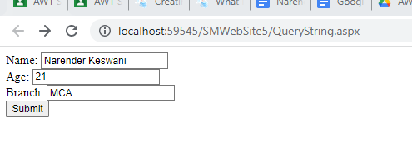

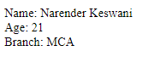

1. **ViewState:**

**SOURCE CODE:**

**ViewState.aspx:**

<%@ Page Language="C#" AutoEventWireup="true" EnableViewState="true" EnableViewStateMac="true" CodeFile="ViewState.aspx.cs" Inherits="ViewState" %>

<!DOCTYPE html>

<html xmlns="http://www.w3.org/1999/xhtml">

<head runat="server">

<title></title>

</head>

<body>

<form id="form1" runat="server">

<div>

Name: <asp:TextBox ID="name" runat="server"></asp:TextBox>

<br />

Age: <asp:TextBox ID="age" runat="server"></asp:TextBox>

<br />

Branch: <asp:TextBox ID="branch" runat="server"></asp:TextBox>

<br />

<asp:Button ID="Button1" runat="server" OnClick="Button1_Click" Text="Submit" />

<asp:Button ID="Button2" runat="server" OnClick="Button2_Click" Text="Restore"/>

</div>

</form>

</body>

</html>

**ViewState.aspx.cs:**

using System;

using System.Collections.Generic;

using System.Linq;

using System.Web;

using System.Web.UI;

using System.Web.UI.WebControls;

public partial class ViewState : System.Web.UI.Page

{

protected void Page_Load(object sender, EventArgs e)

{

}

protected void Button1_Click(object sender, EventArgs e)

{

ViewState["name"] = name.Text;

name.Text = "";

ViewState["age"] = age.Text;

age.Text = "";

ViewState["branch"] = branch.Text;

branch.Text = "";

}

protected void Button2_Click(object sender, EventArgs e)

{

name.Text = ViewState["name"].ToString();

age.Text = ViewState["age"].ToString();

branch.Text = ViewState["branch"].ToString();

}

}

**OUTPUT:**

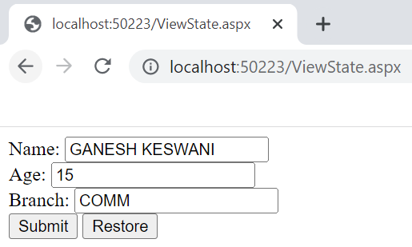

1. **HiddenFields:**

**SOURCE CODE:**

**HF.aspx:**

<%@ Page Language="C#" AutoEventWireup="true" CodeFile="HF.aspx.cs" Inherits="HF" %>

<!DOCTYPE html>

<html xmlns="http://www.w3.org/1999/xhtml">

<head runat="server">

<title></title>

</head>

<body>

<form id="form1" runat="server">

<div>

Name: <asp:TextBox ID="name" runat="server"></asp:TextBox>

<br />

Age: <asp:TextBox ID="age" runat="server"></asp:TextBox>

<br />

Branch: <asp:TextBox ID="branch" runat="server"></asp:TextBox>

<br />

<asp:Button ID="Button1" runat="server" OnClick="Button1_Click" Text="Submit" /> <br />

<asp:HiddenField ID="HiddenField1" runat="server"></asp:HiddenField>

<br />

<asp:HiddenField ID="HiddenField2" runat="server"></asp:HiddenField>

<br />

<asp:HiddenField ID="HiddenField3" runat="server"></asp:HiddenField>

<br />

<asp:Label ID="Label1" runat="server"></asp:Label>

<br />

<asp:Label ID="Label2" runat="server"></asp:Label>

<br />

<asp:Label ID="Label3" runat="server"></asp:Label>

<br />

</div>

</form>

</body>

</html>

**HF.aspx.cs:**

using System;

using System.Collections.Generic;

using System.Linq;

using System.Web;

using System.Web.UI;

using System.Web.UI.WebControls;

public partial class HF : System.Web.UI.Page

{

protected void Page_Load(object sender, EventArgs e)

{

}

protected void Button1_Click(object sender, EventArgs e)

{

HiddenField1.Value = name.Text;

HiddenField2.Value = age.Text;

HiddenField3.Value = branch.Text;

Label1.Text = HiddenField1.Value.ToString();

Label2.Text = HiddenField2.Value.ToString();

Label3.Text = HiddenField3.Value.ToString();

}

}

**OUTPUT:**

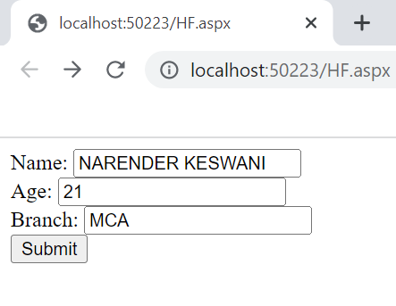

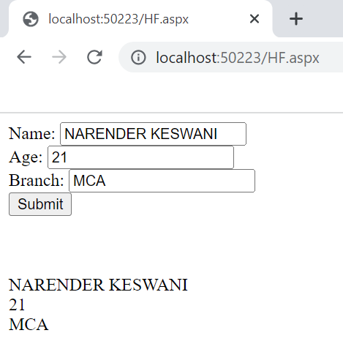

1. **ApplicationState:**

**SOURCE CODE:**

**ApplicationState.aspx:**

<%@ Page Language="C#" AutoEventWireup="true" CodeFile="ApplicationState.aspx.cs" Inherits="ApplicationState" %>

<!DOCTYPE html>

<html xmlns="http://www.w3.org/1999/xhtml">

<head runat="server">

<title></title>

</head>

<body>

<form id="form1" runat="server">

<div>

Name: <asp:TextBox ID="name" runat="server"></asp:TextBox>

<br />

Age: <asp:TextBox ID="age" runat="server"></asp:TextBox>

<br />

Branch: <asp:TextBox ID="branch" runat="server"></asp:TextBox>

<br />

<asp:Button ID="Button1" runat="server" OnClick="Button1_Click" Text="Submit" />

</div>

</form>

</body>

</html>

**ApplicationState.aspx.cs:**

using System;

using System.Collections.Generic;

using System.Linq;

using System.Web;

using System.Web.UI;

using System.Web.UI.WebControls;

public partial class ApplicationState : System.Web.UI.Page

{

protected void Page_Load(object sender, EventArgs e)

{

}

protected void Button1_Click(object sender, EventArgs e)

{

Application["name"] = name.Text;

Application["age"] = age.Text;

Application["branch"] = branch.Text;

Response.Redirect("AS2.aspx");

}

}

**AS2.aspx:**

<%@ Page Language="C#" AutoEventWireup="true" CodeFile="AS2.aspx.cs" Inherits="AS2" %>

<!DOCTYPE html>

<html xmlns="http://www.w3.org/1999/xhtml">

<head runat="server">

<title></title>

</head>

<body>

<form id="form1" runat="server">

<div>

Name: <asp:Label ID="name" runat="server"></asp:Label>

<br />

Age: <asp:Label ID="age" runat="server"></asp:Label>

<br />

Branch: <asp:Label ID="branch" runat="server"></asp:Label>

<br />

</div>

</form>

</body>

</html>

**AS2.aspx.cs:**

using System;

using System.Collections.Generic;

using System.Linq;

using System.Web;

using System.Web.UI;

using System.Web.UI.WebControls;

public partial class AS2 : System.Web.UI.Page

{

protected void Page_Load(object sender, EventArgs e)

{

if (Application["name"] != null)

{

name.Text = Application["name"].ToString();

}

if (Application["age"] != null)

{

age.Text = Application["age"].ToString();

}

if (Application["branch"] != null)

{

branch.Text = Application["branch"].ToString();

}

}

}

**OUTPUT:**

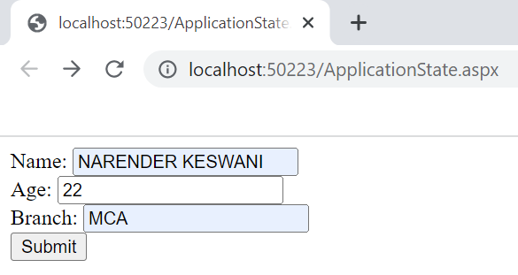

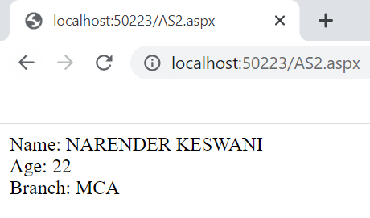

**CONCLUSION:**

From this practical, I have learned and implemented client & server-side session management in asp.net.